1)

a)

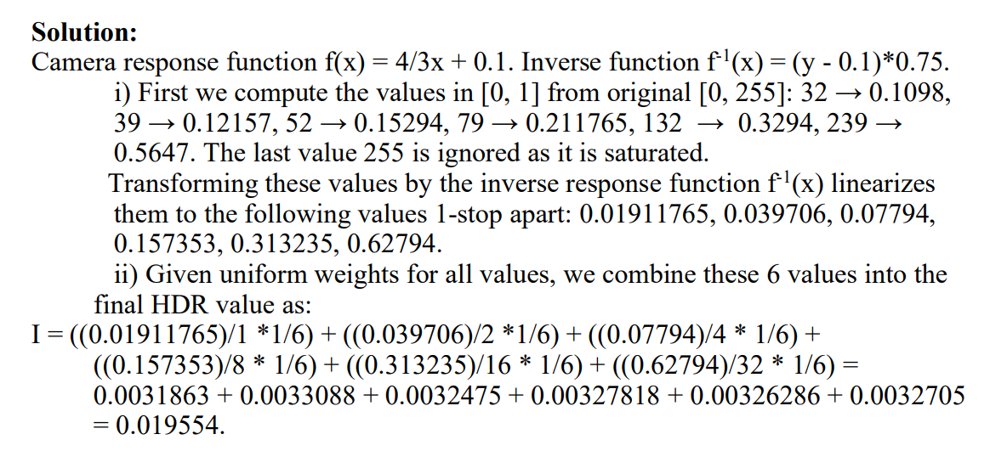

iii) ¼ exposure so 1/16. 3 stops apart so 1/16 * 8 = ½. 2x ISO = ½*2 = 1. ND=3.0 so 10^3x reduction so 1/1000

iv)

Shutter Speed – most range but is sensitive to motion- If anything is moving it will blur

Aperture – allows in more or less light. Can allow you to shoot when you have less light available. but [lens flare](https://link.springer.com/referenceworkentry/10.1007%2F978-0-387-31439-6_481) “is prominent when the aperture is large and the camera has a wide field of view”, so either accept glare or have a shallow depth of field.

ISO – Brightens image without changing how much light is actually captured. Noise increases the higher you go with ISO so you wanna keep this low

ND – Blocks light without affecting colour (meant to anyway). Allows you to have long exposures without overexposing your image. Not perfectly neutral and can actually affect colour. Also you need to buy and carry around a whole bunch of them for the different stops.

b)

i) Dimension is mn x pq. m x n is the resolution of the camera and p x q is the resolution of the projector. So 12000000 x 4000000 is the resolution of T

ii)

Sequential Measurements: 4000 x 3000 = 12000000

Parallel Measurements (Adaptive Measurement): ln(12000000) = 16-ish

iii) Resolution of (u,v) is (20x20) and resolution of (s,t) is (200x200)

c)

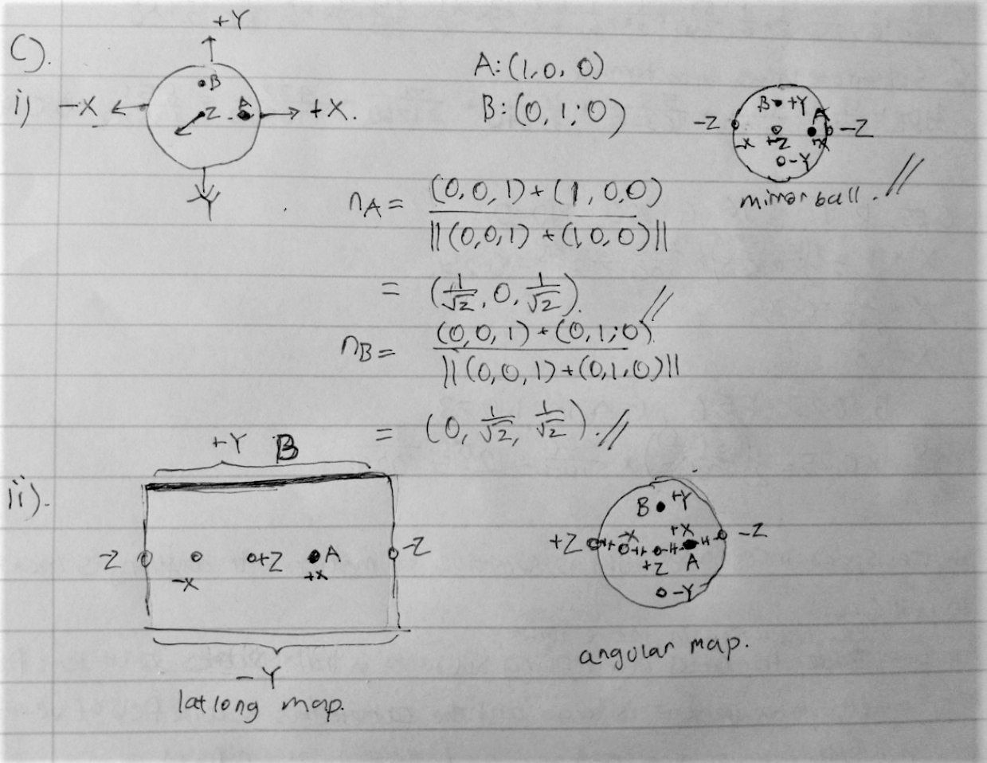

iii) Diffuse ball remains unsaturated in bright sunlight. Can use the diffuse ball to estimate the sun’s energy alpha.

iv) Use mirror ball, diffuse ball and black ball together and you can measure natural illumination. Or maybe deep learning?

d)

I) Types of Conventional Light stages:

1. Single light source (rotated by a rope & pulley system around subject)  
   + Cheap  
   + Any resolution  
   - Slow  
   - Difficult to automate
2. Light arc (rotated around subject)  
   + High Resolution  
   + Faster  
   - Resolution still limited by number of lights fit in arc
3. Light dome  
   + Fastest  
   + Full Automated  
   - Expensive  
   - Complex  
   - Low resolution, limited by number of lights fit in dome

ii) Conventional discrete light stage – not great because of the gaps in the lights. You get aliasing when you there are sharp specular reflections. Also jumps in shadows and caustics.

Dual light stage – Use a laser and camera. Need a high speed camera with 180-degree fisheye lens. Laser is very powerful and you can’t measure humans. But you have no gaps because it is continuous

Iii) The nyquist sampling rate is two times the highest frequency of the input. If you have a discrete light stage and a very specular surface, the response can sit between the samples taken so it’s never captured. You need to increase the sampling rate to be able to capture it. Neural networks can interpolar highly specular reflectance functions from a small number of images.

2) a)

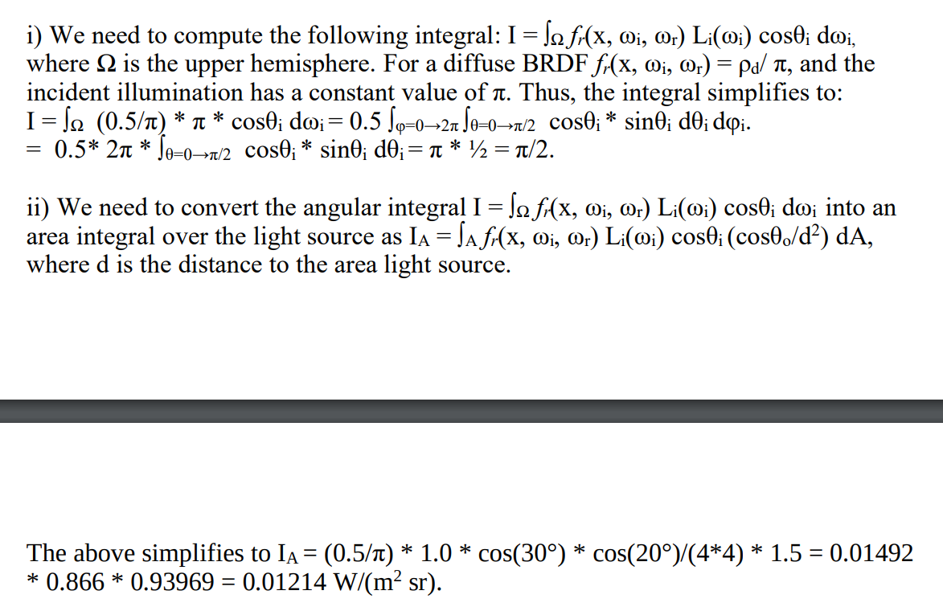

iii) 0.025 = ((1-eta)^2)/((1+eta)^2) => eta = 1.37562

Theta_B = arctan(1.37562/1) = 53.9845

R(53.9845) = 0.025 + (1-0.025)(1 – cos(53.9845))^5 = 0.03657

T = 1 – 0.03657 = 0.96343

Iv) At Brewster’s angle, the reflected component consists of only perpendicular polarized light, whilst the transmitted component consists of only parallel polarized light.

B)

i)

= D(ω_h) G(ω_r, ω_i) F_r(ω_h) / 4 (n ꞏ ωi) (n ꞏ ωr)

Where:

D is the distribution term that describes the jaggedness of the grooves

G is the geometry term that describes the masking and shadowing effect of grooves

F is the Fresnel term that describes Fresnel reflection

And the denominator is a normalisation term

ii) You measure the D, G, F terms and replace the terms above with the measured values. Product of 3 separate 1D factors. 1 row in image per material so you have many more parameters. Reparameterise to be symmetric about the half vector and the matrix goes from full rank to rank 1 which means less to store?? Also can halve the number of phi bins by using reciprocity and only keeping the 180 degrees instead of 360 cause it should be the same

iii) Poulin-Fournier Model.

Parametrized by d and h  
where:   
 d is distance between cylinders  
 h is height of cylinders

Good for anisotropic fabrics such as satin and velvet

C)

i)

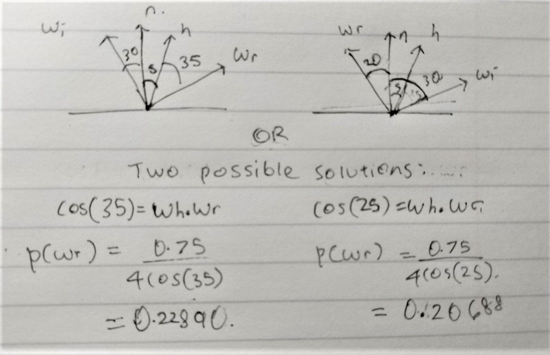

ii) Lecture 9, slide 20 has the cdf for theta and phi. Need to sample phi first then theta because theta is dependent on phi.

Phi = arctan(sqrt((nu+1)/(nv+1)) tan(2*pi*u2)) = arctan(sqrt((20+1)/(100+1)) tan(2*pi*0.7)) = 0.95168

S= cos(Phi*nu^2)^2 + sin(Phi*nv^2)^2 = 1.6369

Theta = acos((1-u1)^(1/(s+1))) = acos((1-20)^(1/(1.6369+1))) = 0.40562

(Theta, Phi) = (0.95168, 0.40562) rad = (23.24, 54.53) degrees

D)

i) Having a spherical sample Is good as it means we can take advantage of spherical harmonics. SH function can be rotated over the sample by using a rotation matrix on the individual SH basis functions themselves. This implies that given a fixed set of SH measurements, we can computationally rotate them after to whatever direction we desire, consequently getting the gradient in that direction. This means we don’t need to take unique measurements for each surface normal (Which will be the case if we had an irregularly shaped sample)

As irradiance is well-approximated for the first 9 SH components, and isotropic BRDFs are symmetric (Thus only needing the middle SH components), they only need 3 measurements.

ii) A linear light source means you can just scan the sample linearly from top to bottom. Order n compared to n^2 with a point light source where you have to move in 2 axes.

iii) You just need to store the parameters like the mean and std for a gaussian

iv) Deep learning? Unet architecture that can predict the spatially varying appearance parameters of a planar sample seen under flash illumination. Estimated parameters of the planar sample include spatially varying diffuse albedo, surface normal, specular albedo and roughness.

3)

a) i)

Pdf = 0.05, 0.15, 0.05, 0.05, 0.25, 0.05, 0.15, 0.10, 0.05, 0.1

Cdf = 0.05, 0.20, 0.25, 0.30, 0.55, 0.60, 0.75, 0.85, 0.90, 1.0

Sample 1 = 0.55 => index 5 => 25

Sample 2 = 0.9 => index 9 => 5

Sample 3 => 0.25 => index 3 => 5

Sample 4 => 0.75 => index 7 => 15

ii) Mean = 12.5

Iii) Var = 91.67

iv) Energy Re-distribution Path Tracing? Correlated visibility sampling? Deep learning? No idea

b)

i) First you need to calculate your SH coefficients for the numbers of orders and degrees that you want. Then when you want to compute irradiance you multiply each basis function by the coefficient and sum them together to get an approximation of the environmental illumination. It is efficient because you only need to store the coefficients and the basis functions but not the environment map itself and you no longer need to do any ray tracing.

Ii) You use a global illumination rendering system and simulate ambient occlusion for each vertex and then store that result as a SH transfer vector of SH coefficients per vertex. Then you can use the vector by just multiplying the vector by the illumination coefficients at runtime.

iii) SH basis functions can be used to store the radiance estimate and then just by applying rotation matrices to the coefficients you can create view dependent interreflection effects. Need different amount of orders based on if your material is diffuse or glossy.

iv) Instead of just discarding rays like in MC sampling, you mutate good existing paths to better capture the light. With just MC, if you have a small amount of light coming from a small area, your image will be noisy but with MLT we can sample the light more often once it’s found. The advantage is we have local exploration and less noise results.

c)

i) 1000 * (0.65/pi) * (0.15/(pi/0.5^2)) = 2.46970385

Photon density = 1000/pi*0.5^2

ii)

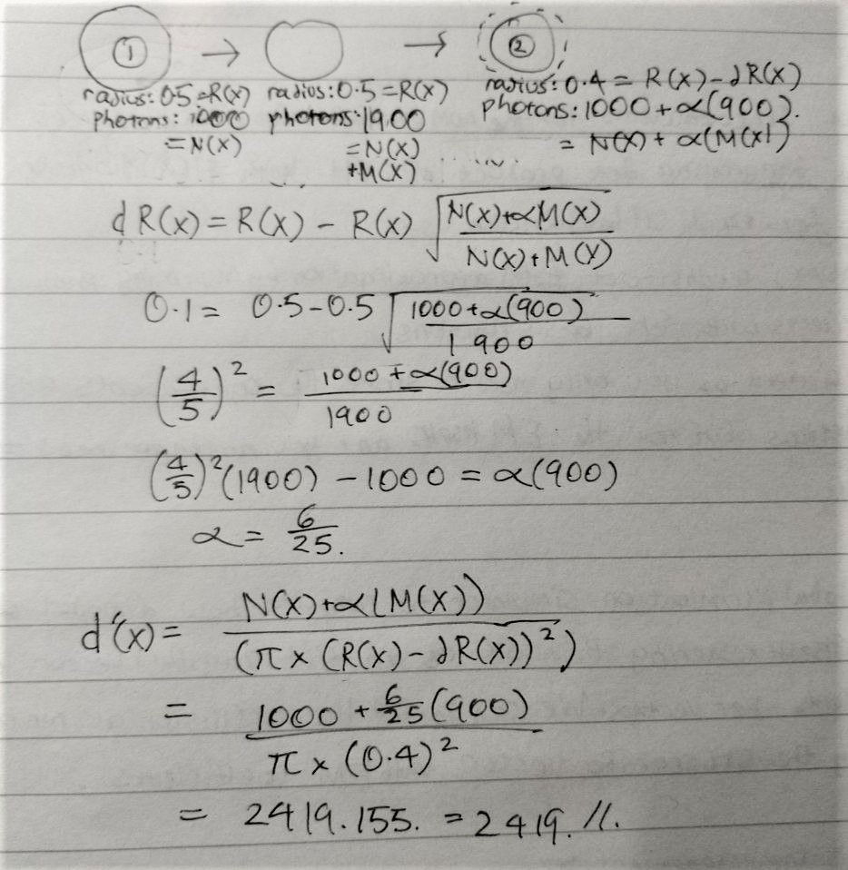

iii) 0.2235

iv) 0.6536

d)

i) Bound the product distribution with the product of max of one function with the distribution of the other function. You have one function that you can sample from such as a Gaussian, so in the first round you sample from this and then in a second round you generate another random number which is scaled by the max of the function. If the sample is below the value of fmax * q then you accept and otherwise you reject. Acceptance probability is in lecture 10 slide 18. It means that the tighter the bound, the more efficient the sampling because you get fewer rejections. You want the smallest difference between the two distributions basically.

Ii) The noise is due to the unsampled product distribution; if we sample from the EM, the noise is from the unsampled BRDF, and vice versa. A solution might be to get additional samples from the other unsampled distribution and combining them with Multiple Importance Sampling.

Iii) Do bidirectional path tracing and then combine using multiple importance sampling?